**Canvas - Work with Gradient**

Please create new html file and save it on your week 6 folder. Copy next code instead of “<body></body>”

We need to declare canvas element and draw a rectangular - fillRect(*x,y,width,height*)

<http://www.w3schools.com/tags/canvas_createlineargradient.asp>

<body>

<div id="outer">

<canvas id="canvas1" width="400" height="400">

Your browser doesn't support the canvas! Try another browser.

</canvas>

</div>

<script>

var mycanvas=document.getElementById("canvas1");

var cntx=mycanvas.getContext('2d');

var mygradient=cntx.createLinearGradient(30,30,300,300);

mygradient.addColorStop(0,"#ffdd30");

mygradient.addColorStop(0.4,"#3de6a6");

mygradient.addColorStop(0.5,"#003333");

mygradient.addColorStop(0.82,"#00ccee");

mygradient.addColorStop(1,"#333333");

cntx.fillStyle=mygradient;

cntx.fillRect(0,0,400,400);

</script>

</body>

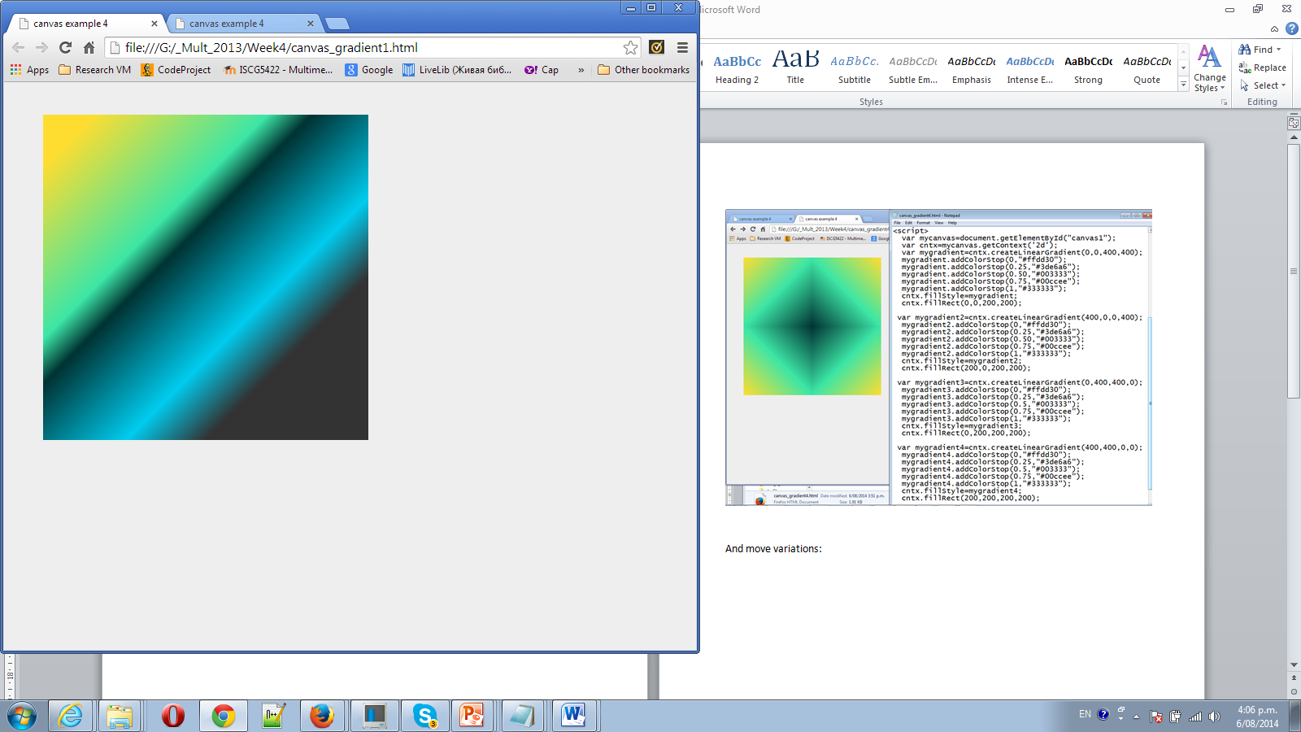

2 We want to do two rectangulars, and we make their size smaller ( 200px)

cntx.fillRect(0,0,200,200); -start position ( x=0, y=0; width=200; height =200)

cntx.fillRect(200,200,200,200); position ( x=200, y=200; width=200; height =200) Note: Second rectangular coordinates are x=200; y=200; try different gradient for second rectangular cntx.createLinearGradient (*x0,y0,x1,y1*);(x0, y0- start point, x1, y1- end point).

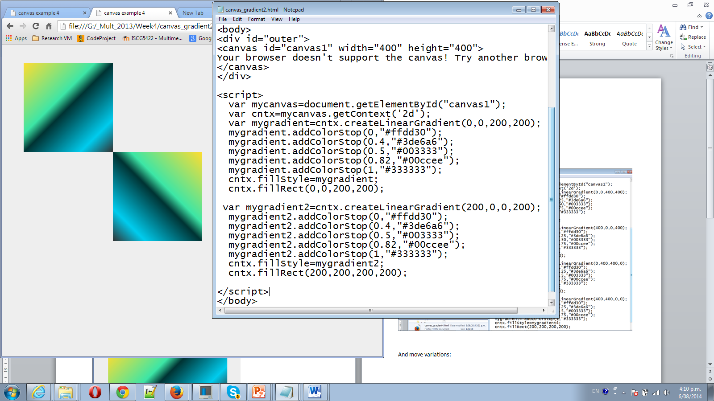

Final version: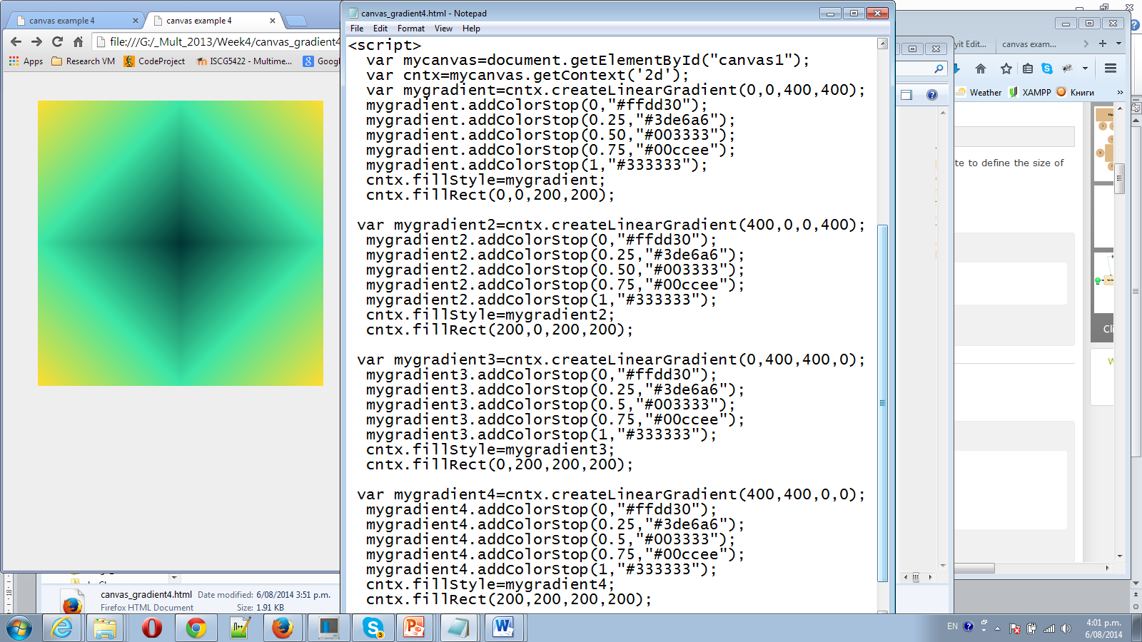

And move variations:

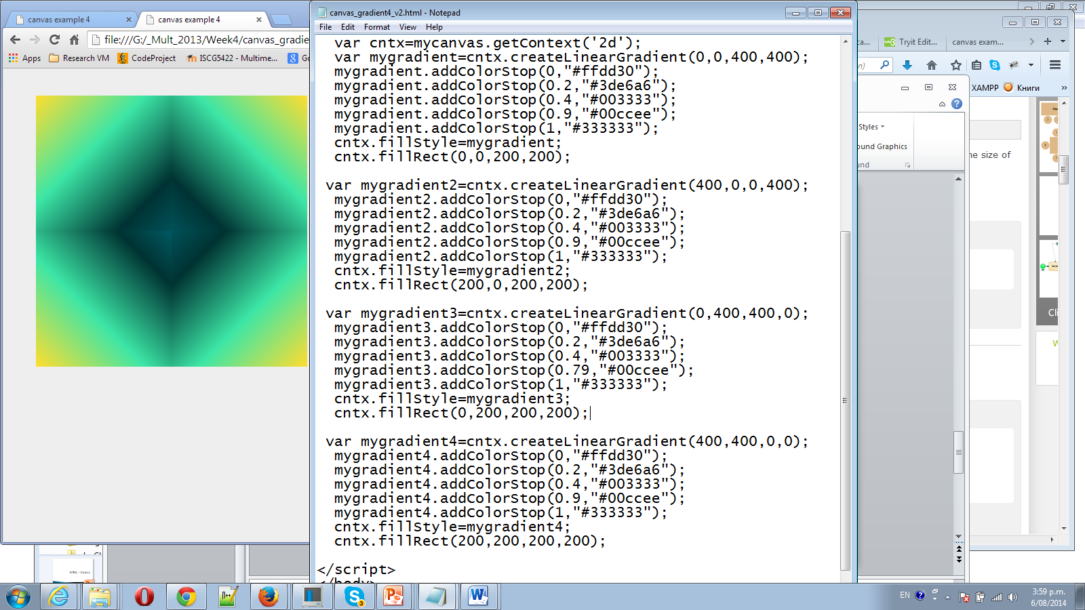

Try to change it on Radial Gradient createRadialGradient(*x0,y0,r0,x1,y1,r1*);

Please note that in the first rectangular createLinearGradient is change on createRadialGradient. How to use it you can find on: <http://www.w3schools.com/tags/canvas_createradialgradient.asp>

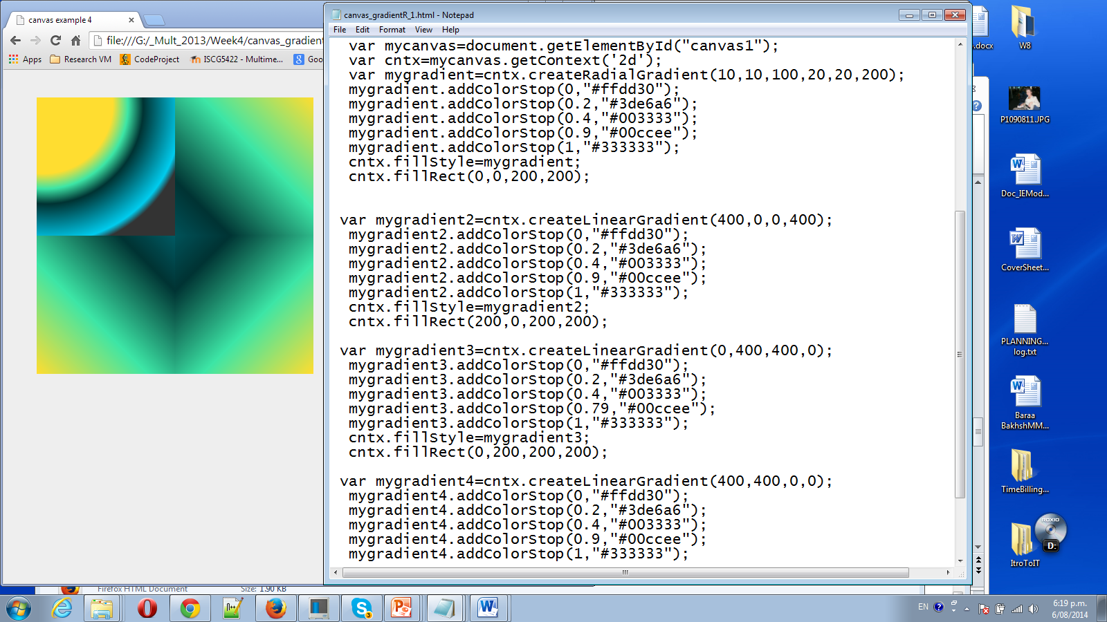

Challenge- try to create next picture -

